Temperature and Humidity Indicator

Description:
The Temperature and Humidity Indicator project is designed to measure and display environmental temperature and humidity.
In this project, a DHT11 sensor is used to sense temperature and relative humidity, and the values are displayed through the Serial Monitor.
This project helps students understand sensor interfacing, data acquisition, and environmental monitoring using Arduino.

Block Diagram:
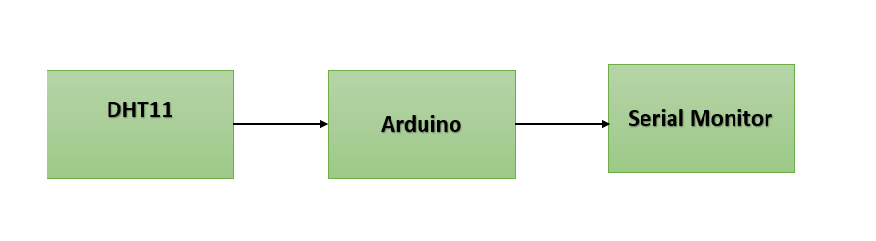

Pinout / Circuit Connection:
DHT11 DATA → Arduino Pin 2
DHT11 VCC → 5V
DHT11 GND → GND
Power supply: 5V

Components Required:
Arduino Uno / Nano
DHT11 Temperature and Humidity Sensor
Jumper wires
Breadboard

Working Principle:
The DHT11 sensor contains a temperature sensor and a humidity sensor along with an internal ADC.
It measures ambient temperature in degrees Celsius and relative humidity in percentage.
The sensor sends digital data to the Arduino through a single data pin.
Arduino reads this data and displays the temperature and humidity values on the Serial Monitor.

Operation (Step-by-Step):
- Connect the DHT11 sensor to the Arduino as per the circuit diagram.
- Connect the Arduino to the computer using a USB cable.
- Install the DHT sensor library in the Arduino IDE.
- Upload the temperature and humidity indicator program to the Arduino.
- Open the Serial Monitor.
- The current temperature and humidity values are displayed continuously.

Arduino Code:
#include <DHT.h>

#define DHTPIN 2 // DHT11 data pin
#define DHTTYPE DHT11

DHT dht(DHTPIN, DHTTYPE);

void setup() {
Serial.begin(9600);
dht.begin();
}

void loop() {
float humidity = dht.readHumidity();
float temperature = dht.readTemperature(); // Celsius

if (isnan(humidity) || isnan(temperature)) {
Serial.println("Failed to read from DHT sensor!");
return;
}

Serial.print("Temperature: ");
Serial.print(temperature);
Serial.print(" °C | Humidity: ");
Serial.print(humidity);
Serial.println(" %");

delay(2000);
}

Conclusion: (Predefined/self-written)
The Temperature and Humidity Indicator using DHT11 provides a simple and effective method for monitoring environmental conditions.
This project introduces students to sensor interfacing and real-time data monitoring.
It forms the basis for advanced applications such as weather stations, smart agriculture, and IoT-based monitoring systems.
For Your References:
[1] Arduino, “DHT Sensor Library,” Arduino.cc. [Online]. Available: https://www.arduino.cc/reference/en/libraries/dht-sensor-library/. [Accessed: Jan. 15, 2026].
[2] Aosong Electronics Co., Ltd., “DHT11 Temperature and Humidity Sensor Datasheet,” Aosong Electronics. [Online]. Available: https://components101.com/sensors/dht11-temperature-sensor. [Accessed: Jan. 15, 2026].

